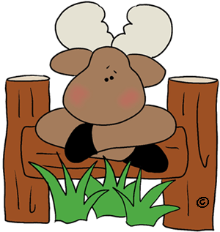Toddler Sleep Habit Form
Child’s Name______________________________________
Please provide a description of your child’s sleep habits and methods:_________________________________________________________________________________________________________________________________________________________________________________________________________________________________________________________________________________________________________________________________________

Does your child have a special item they sleep with each day? ____________________
Will you be providing a blanket from home for your child to rest with? ______________
Do any items need to be transported back and forth from home each day? ___________
Thank you. We strive to provide the most pleasant environment possible for little ones to rest, recharge and build immunity.
Merry Moose Staff

